**WIA2001/WIB2001**

**DATABASE**

**SEM 1, 20116/2017**

**Tutorial 3**

1. Suppose you are working within the framework of the conceptual model in Figure 1 .

**Figure 1 : ERD for Workshop**

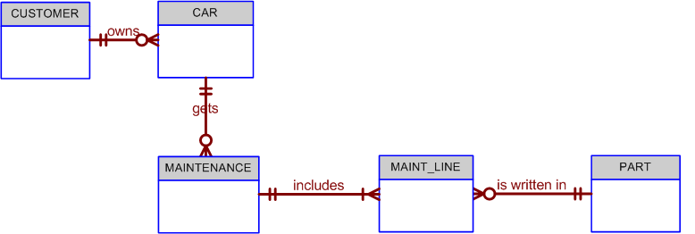

Given the conceptual model , write the business rules that are reflected in it.

1. Draw an ERD based on the following descriptions :

* The staff are responsible for orders, which are identified by an ORDER-NO and have an ORDER-DATE, DESCRIPTION, and QUOTED-PRICE. Each order is from one customer. Only one Staff member is responsible for a given order, but a Staff member may be responsible for many orders.
* The organization manufactures the order in a series of jobs. The Staff member responsible for an order makes formal requests to sections to carry out these jobs. The requests are identified by a REQUEST-NO. They nominate a START-DATE and an END-DATE for each request.
* A number of jobs can be created by a section in response to a request. Each job is identified by a JOB-NO and has a COST. All jobs for one request go to the same section, which is identified by SECTION-ID and has one MANAGER.
* Each job uses a QTY-USED of one or more materials. Materials are identified by MAT-ID and have a MAT-DESCRIPTION.
* Staff in the organisation are identified by a STAFF-ID and have a SURNAME, FIRST-NAME and DATE-OF-BIRTH.

1. Discuss the difference between a composite key and a composite attribute. How would each be indicated in an ERD?
2. Create an ERD based on the Crow’s Foot model, using the following requirements:

* An INVOICE is written by a SALESREP. Each sales representative can write many invoices, but each invoice is written by a single sales representative.
* The INVOICE is written for a single CUSTOMER. However, each customer can have many invoices.
* An INVOICE can include many detail lines (LINE), each of which describes one product bought by the customer.
* The product information is stored in a PRODUCT entity.
* The product’s vendor information is found in a VENDOR entity.
* NOTE :

The ERD must reflect business rules that you are free to define (within reason). Make sure that your ERD reflects the conditions you require. Finally, make sure that you include the **attributes** that would permit the model to be successfully implemented.